Maths   | Faculty | Year group | Subject | Exam board |  | Type of assessment | Key assessment dates
 | Mathematics | 12 | AQA Level 3  Mathematical studies | AQA  Level 3  Certificate Mathematical studies 1350/2A  Option A |  | 100% exams with 2 papers  Paper 1 60 marks 90 min  Paper 2 60 marks 90 min  Students will receive Preliminary materials In March 2023. | In Class Test: Mid October 2021  Mocks PPE 2: Early December 2021  Mocks PPE 3: Early March 2022.  Final AS Exam provisional dates:  Paper 1: tbc 2023 (calc)  Paper 2: tbc 2023 (calc)
Curriculum information
Autumn term | Spring term | Summer term
  Data and Sampling | Fair representation
  Measure of spread | Standard deviation
  Simple and Compound interest | Cumulative frequency and Histograms
  Box plot | Personal finance
  Income tax and National interest | APR- Mortgage
  Saving and investment | Exchange rate
  Modelling and estimation | Modelling gulf strem
  Standard form | Estimation technique
  Stating assumption | Lessons from history
  Critical analysis | Clarity
  Sampling and Trialling | Saving
  Investment | AER
  Year 13 contents
  Critical analysis | Selective data
  The normal distribution | The standard normal distribution

Recommended resources |  |  |  |  | Homework frequency |  |  | Homework/independent study expectations
Compulsory textbooks  AQA Advanced Maths Level 3 certificate Mathematical studies  ISBN 978-0-19-836593-8  Additional Revision books  AQA Level 3 Mathematical studies  (Core Maths)  ISBN: 978-14718-6375-2  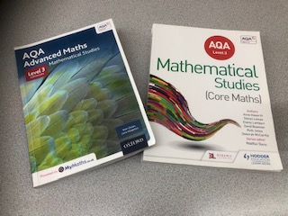 |  |  |  |  |   Three times a week :  Hw1 Past learning (What students have learned previously)  Hw2 Present learning (What students are learning)  Hw3 Future learning (What students will  be learning)  Students submit homework on SHOW MY HOMEWORK.  Maths Equipment:  Every student must bring equipment to every lesson & use it at home for homework too. These include: a ruler, compass, protractor & scientific calculator.  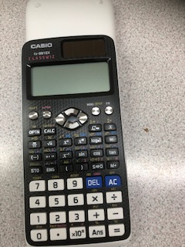 |  |  | All homework completed on time and to a high standard  Diagrams must be drawn in pencil, using a ruler where appropriate.  Other free Websites to support independent study:  www.hoddereducation.co.uk/dynamiclearing  www.oxfordsecondary.co.uk  www.aqa.org.uk  www.mathshubs.org.uk  www.amsp.org.uk
Head of Faculty |  |  |  |  | Head of Key Stage 5 |  |  | Extra-curricular opportunities
Mrs D Whyte  dwhyte@edmonton.enfield.sch.uk |  |  |  |  | Mr S Alibagi  salibagi@edact.org.uk |  |  | Ask your form teacher for information about the course run by different university.

