Maths   | Faculty | Year group | Subject | Exam board |  | Type of assessment | Key assessment dates
 | Mathematics | 9 | GCSE Maths | EDEXCEL 1MA1 (Grades 9-1)  Two Tiers:  Higher (Grades 9-4) or Foundation (Grades 5-1) |  | GCSE exams in May/June 2024.  100% exams with 3 papers each 1 ½ hours long.  (one non-calculator and two calculator exam papers) | Internal cumulative assessments.  Assessment 1: Oct 2021  Assessment 2: Jan 2022  Assessment 3: April 2022  End of year 9 exam June 2022
Curriculum information
Autumn term | Spring term | Summer term
  Higher | Foundation
  Unit 4: Fractions, Ratio & Percentages | Unit 4: Fractions & Percentages
  Unit 5: Angles & Trigonometry | Unit 6: Angles
  Unit 6: Graphs | Unit 9: Graphs
  Higher | Foundation
  Unit 7: Area & volume | Unit 8: Perimeter, area & volume 1
  Unit 8: Transformations & constructions | Unit 10: Transformations
  Unit 9: Equations and inequalities | Unit 5: Equations, Inequalities & Sequences
  Higher | Foundation
  Unit 10: Probability | Unit 13: Probability
  Unit 11: Multiplicative reasoning | Unit 14: Multiplicative reasoning

Recommended resources |  |  |  |  | Homework frequency |  |  | Homework/independent study expectations
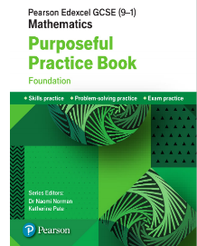  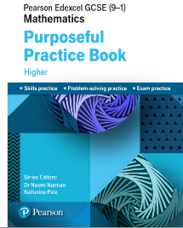  Homework book:  This books are accessible online via the  school (you may wish to buy separately):  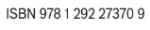  Set 1-2: Higher – Purposeful Practice Book  Set 3-5: Foundation – Purposeful Practice Book  Set 6: Worksheets |  |  |  |  |   Twice a week: one from the homework textbook and another from website Hegarty Maths, https://hegartymaths.com/ . This should take between 90 minutes in total to complete per week. Work is recorded on ‘Show My Homework’ for parents to track: click the ‘Show My Homework’ icon on our school website.  Maths Equipment:  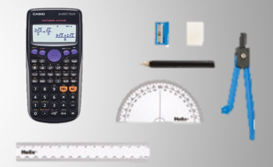  Every student must bring equipment to every lesson & use it at home for homework too. These include: a ruler, compass, protractor & scientific calculator.  Setting:  Students are set by ability. Set 1-2 are taught the higher, Set 3 is a mixture of higher/foundation & Set 4-6 are taught the foundation curriculum. |  |  | All homework completed on time and to a high standard  Diagrams must be drawn in pencil, using a ruler where appropriate.  Other free Websites to support independent study:  www.studymaths.co.uk (revision notes)  www.mathsgenie.co.uk GCSE Higher Past papers & hand written solutions  www.mathsmadeeasy.co.uk GCSE questions by topic  http://www.onmaths.com/  GCSE questions and revision  https://corbettmaths.com/  Exam papers, 5-a-day, revision
Head of Faculty |  |  |  |  | Head of Key Stage 4 (Sept 2021) |  |  | Extra-curricular opportunities
Mrs D Whyte  dwhyte@edmonton.enfield.sch.uk |  |  |  |  | Ms M Behjet |  |  | Ask your teacher for information about the maths club.

