Maths   | Faculty | Year group | Subject | Exam board | Type of assessment |  | Key assessment dates
 | Mathematics | 7 | KS3 Maths | N/A | Test at the end of every 4 chapters (approximately)– these are done in class and last 50 minutes. Students receive a check sheet for each topic to help aid revision, although previously taught topics are also included in the test to review prior learning. |  | Internal end-of-term assessments.  Baseline test: Sept 2021  Assessment 1: Jan 2022  Assessment 2: March 2022  Assessment 3: End of year 7 test June 2022
Curriculum information
Autumn term | Spring term | Summer term
1 Analysing and displaying data  2 Number skills  3 Expressions, functions and formula  4 Decimals and measures | 5 Fractions and percentages  6 Probability  7 Ratio and proportion | 8 Lines and angles  9 Sequences and graphs  10 Transformations

Recommended resources |  |  |  |  |  | Homework frequency |  | Homework/independent study expectations
Homework: Will be issued as a combination of worksheets and Hegarty maths tasks, put on ‘Show My Homework’, as well as work completed from the independent workbooks.  You are welcome to purchase additional revision guides or practice books if you wish.  Examples  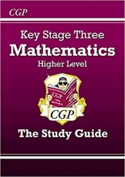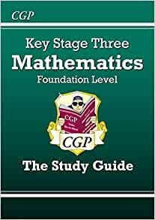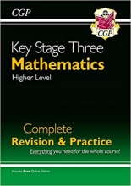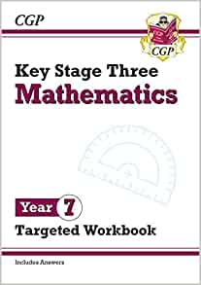  We would also recommend the websites referenced on this sheet. |  |  |  |  |  |   Twice a week: one from the homework independent textbook and another from the Hegarty maths. This should take between 60-90 minutes to complete. Work is recorded on ‘Show My Homework’ for parents to track: click the ‘Show My Homework’ icon on our school website.  Maths Equipment - SPRAC:  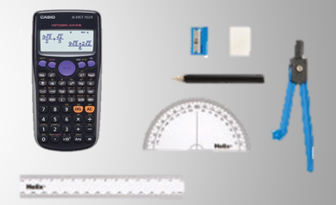  Every student must bring equipment to every lesson & use it at home for homework too. These include: a ruler, compass, protractor & scientific calculator.  Setting:  Students are set by ability. |  | All homework completed on time and to a high standard  Diagrams must be drawn in pencil, using a ruler where appropriate.  Other free websites to support independent study:  BBC Bitesize: http://www.bbc.co.uk/education  KS3 Student Resources:  http://www.emaths.co.uk/  Revision Notes:  www.studymaths.co.uk  https://corbettmaths.com/  5-a-day revision
  http://www.hegartymaths.com/ (Provided)
Head of Faculty |  |  |  |  |  | Head of Key Stage 3 |  | Extra-curricular opportunities
Mrs Danielle Whyte  dwhyte@edact.org.uk |  |  |  |  |  | Ms Pinar Tilkidag  ptilkidag@edact.org.uk |  | Ask your teacher for information about the maths club.

