Sports (Football, Netball and Basketball) Tour 2020

Monday 16th March 2020
Dear Parent/Guardian,

Unfortunately, due to the government advice against international school trips, the sports tour has been cancelled.

A full refund is being secured from the tour company and school’s travel insurance, which will be returned to you as soon as possible.

Passport and EHIC can be collected from the PE office. Thank you for your understanding and patience.

If you have any questions, please feel free to contact me using the number below or on the following email address; opottinger@edmonton.enfield.sch.uk.

Yours faithfully,
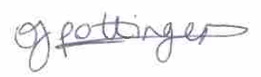
Miss O Pottinger
Deputy Head of PE
Tour Party Leader

