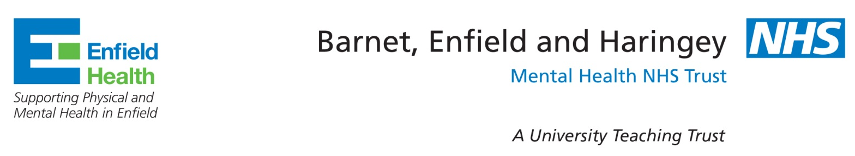
To the Parent or Carer of Children’s Immunisation Team
Cedar House
St Michael Hospital
Gater Drive
Enfield
EN2 0JB
IMMUNISATION: (for Sat Nav use EN2 0JA)

Email: beh-tr.enfieldimmunisationteam@nhs.net
Telephone: 0208 702 3324
18/03/20

Dear Parent / Carer
Re: School Holiday Community Immunisation Clinic Closures

In light of the present developments concerning the corona virus outbreak, we have found it necessary to cancel the school aged community immunisation clinics planned for
Tuesday 7th April and Thursday 16th April at the above location.

The present crisis may continue for a number of months, and we will advise you further when we have more information.

Thank you for your understanding and co-operation.

Yours sincerely,

Ann Rebak
Immunisation Team Leader
Children’s Immunisation Team

