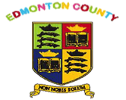
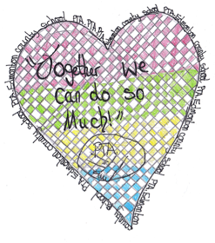
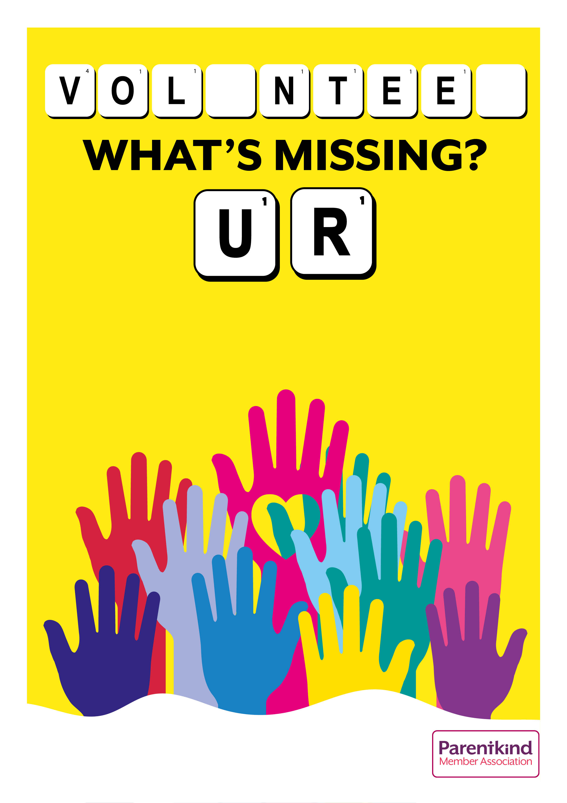
Talk to Ms Phiakkou to find out how to get involved or email: edmontoncountyPTA@yahoo.com

Help us raise vital funds needed to enhance our children's school experience, improve the playground and buy books for the library.

EDMONTON COUNTY PRIMARY PARENT TEACHER ASSOCIATION

